

InhousePharmacy Redesign

Project Report

Date Created:October 17, 2019

Date Last Modified: December 9, 2019

Noah Korner, Adam Eckert, Matthew Bumb, William Tith

**Table of Contents**

Introduction **3**

Purpose 3

Tasks Identified 3

Assumptions 4

Analysis **4**

Personas 4

Task Analysis Tools 6

Task #1 7

Task Detail #1 7

Task #1 Analysis 7

Task #1 Discussion 7

Task #2 7

Task Detail #2 7

Task #2 Analysis 7

Task #2 Discussion 8

Task #3 8

Task Detail #3 8

Task #3 Analysis 8

Task #3 Discussion 8

Prototype and Design **9**

Overview of Prototype and Design Features 9

Task #1 9

Task #1 Design 9

Task #1 Design Justifications 9

Task #1 Prototype 9

Task #1 Prototype Rational 13

Task #2 13

Task #2 Design 13

Task #2 Design Justifications 13

Task #2 Prototype 13

Task #2 Prototype Rational 15

Task #3 15

Task #3 Design 15

Task #3 Design Justifications 15

Task #3 Prototype 15

Task #3 Prototype Rational 17

A/B Testing **18**

Participants 18

Scenarios 18

Equipment 18

Subjective Metrics 18

Quantitative Metrics 19

Test results 19

Conclusions **19**

Discussion of Results 19

Lessons Learned 20

Conclusion 20

Appendices **20**

[Heuristic Evaluation  
https://drive.google.com/open?id=18paak3NkMPL0abxXkULwHXC-2KGIEI8t](#_28h4qwu) 20

[Cognitive Walk-through  
https://drive.google.com/file/d/1zI407Quw63d0kf5HcdvNGG58TDKL5Up-/view?usp=sharing](#_uouivvod0h91) 20

New GUI snapshots 21

Prototype Link: gfi9hu.axshare.com 21

Instructions for Participants 25

Researcher guidelines 25

Background questionnaire 26

Post-session questionnaire 27

# Introduction

## Purpose

InHousePharmacy.vu is a website that sells pharmaceuticals to the public without a prescription. After giving the website a heuristic evaluation (See Appendix 6.1) and a cognitive walkthrough (See Appendix 6.2) it was apparent there were glaring problems in the user experience. Ideally, for a shopping website, goods must be easily searchable and organized in a simple, easy to understand manner. As the website is now, the search results are laid out in an extremely difficult, cluttered manner, making it difficult to see if what you are looking for is both correct and appropriate for your needs, as medications are often listed in separate bulk sizes due to pricing changes, occupying a lot of space. Products are also arranged haphazardly, with different medications entirely being put under the non-labeled brand name and generic columns. This, and awkward ability to manage items in the cart, make buying rather aggravating.

The goal is to lower the time it takes to order a product from InHousepHarmacy.vu. Ordering should not be a complicated hassle that involves excessive scrolling and deciphering of multiple parts of the screen. In addition, it should be easy for a user to manipulate the items inside of their cart. Ideally our changes should make this experience much smoother for the consumer, but our approach may have flaws and benefits that can be fixed and improved upon respectively when revising the design.

## Tasks Identified

The user will be asked to perform 3 main tasks. The reason there are 3 tasks is because each task is fairly simple (less than 3 minutes), but each task tests a part of the redesigned usability of the website.

1. Search for Flixotide, 50mcg dosage accuhaler, add 1 pack to the cart, navigate to the cart, enter order information, and place the order.
2. Search for Kiwof Plus for Small, Medium & Large Dogs medication, add an amount of medicine equivalent to one year (12 months) worth of doses for a 22kg dog to the cart, navigate to the cart, remove it from the cart, and navigate back to the home page.
3. Navigate to the “Men’s Health” page, locate both a name-brand and generic version of the same erectile dysfunction medication(same dosage, some tablet count), and add them both to the cart.

The reason these tasks were identified was the fact that each task was representative of InHousePharmacy.vu ‘s users. With a focus on name-brand versus generic medications, we hope to prove a failure in that area of the website to sufficiently make the difference known. They are also fairly standard tasks for any ecommerce website, however on InhousePharmacy.v, they became cluttered and confusing. Our overall goal was to pick the most representative, typical task of InHousePharmacy’s users and ecommerce sites in general.

## Assumptions

The main assumptions are that the user has computer experience and is familiar with the basics of online ordering, knowing what the purpose of a “shopping cart” is, for example.

# Analysis

## Personas

|  |  |
| --- | --- |
| Persona 1: | “Experienced user” |
| Fictional Name: | “Joseph” |
| Job Title / Major responsibilities: | College student, part time employee |
| Demographics: | 20 years old |
| Goals and Tasks: | He has been asthmatic since childhood and is knowledgeable on the medication he requires. He wants to reliably, efficiently, and cost-effectively acquire the medication he needs to treat his chronic symptoms. |
| Environment: | He is familiar with using eCommerce sites in a number of contexts. He is very busy managing both his classes and a part-time job to pay rent. |
| Quote: | “I already know what I need, just make it quick and affordable to get it.” |
| Picture: |  |

|  |  |
| --- | --- |
| Persona 2: | “Novice user” |
| Fictional Name: | “Michael” |
| Job Title / Major responsibilities: | Software developer |
| Demographics: | 43 years old  Single |
| Goals and Tasks: | As a result of stressful crunch-times at work, he has developed the bad habit of smoking, and is looking for some help in his attempts to stop. He wants to easily sort through and compare different products related to his needs, even without much familiarity with the medical world. |
| Environment: | He is very busy at work and values his free time. He is generally stressed and easily overwhelmed by extraneous steps and information. |
| Quote: | “My life is stressful already. The more easily I can figure out what I need to do, the better.” |
| Picture: |  |

|  |  |
| --- | --- |
| Persona 3: | “Drop-in user” |
| Fictional Name: | “Yuri” |
| Job Title / Major responsibilities: | Self-employed online crafts store owner |
| Demographics: | 31 years old  Married, with a toddler |
| Goals and Tasks: | Yuri wants to easily sort through and compare different products related to her needs. She is already aware of what product she wants and simply wishes to make that purchase online to not disrupt her busy workflow. |
| Environment: | Yuri works on selling crafts online from home and spends most of her time with her toddler. She enjoys bringing her child to the park to relax and play, but, occasionally, allergies can make leaving the house a hassle. |
| Quote: | “Every once in a while, I just order what I need and keep moving with my day.” |
| Picture: |  |

## Task Analysis Tools

The team used several tools in order to sufficiently evaluate the usability of the original website, InHousePharmacy.vu. The team did several, very thorough heuristic evaluations in order to help identify usability problems with the original website. The heuristic evaluation resulted in a score of 70, which is labeled as ‘good’. A ‘good’ evaluation for the website means that “Users should be able to use this system or site with relative case and should be able to complete the vast majority of tasks”. This is definitely true for users of the InHousePharmacy.vu ecommerce site. Most users, after getting over the annoyance and rather odd layout of the website, should be able to complete the vast majority of tasks.

Another task analysis tool the team used was a cognitive walkthrough. Performing a cognitive walkthrough was another great way to help identify usability problems with InHousePharmacy.vu. Cognitive walkthroughs are similar to heuristic evaluations, however they focus more on specific tasks themselves, rather than the usability experience as a whole. Performing a cognitive walkthrough was especially helpful being that the team had brainstormed 3 specific tasks that the user must perform (detailed in the next section). The cognitive walkthroughs helped identify and detail each step in performing a task, as well as identify problems with *specific* tasks. It was a great tool because it helped us identify problem areas, as well as things that the original InHousePharmacy.vu site already did well (therefore the team could keep the same functionality in the prototype).

## Task #1

### Task Detail #1

The user will be asked to search for and add one order of 50mcg Flixotide to their cart and to ‘checkout’. This task seems simple, but on the original website it is actually a fairly complex task. This requires the user to search for (using the search bar) and locate *Flixotide,* an uncommon medication. Next the user must locate the 50mcg quantity, which on the current website is not very intuitively distinguished from the other items. Next they must add it to their cart, and then navigate to their cart. The final steps include inputting personal information to proceed with the checkout. First they must choose either to create an account or continue as a guest. Next they have to select their preferred shipping method, and input their payment information. The final step is for the user to select ‘place order’ and be taken to an order summary page.

### Task #1 Analysis

This task is both relevant and potentially an issue for users due to the issues with the way the website displays many different instances of the same medicine. When a product comes in different doses, it lists out all of the different dosages as independent items within the search bar, which leads to a very cluttered interface that the user has to deal with.

### Task #1 Discussion

Currently, the process would likely be rather frustrating for users due to the search list being less aesthetically pleasing, much larger, and thus more difficult to parse, than it should be. A much better way of going about it would be to put all the options for different dosages on the page of the individual item itself, separate from the search function, above the button to purchase the item. This would be an effective way to compartmentalize the task into more intuitive sub-sections.

## Task #2

### Task Detail #2

The second task the team asked its users to perform was to search for (using the search bar) the *Kiwof Plus for Small, Medium & Large Dogs* medication, add an amount of medicine equivalent to one year (12 months) worth of doses for a 22kg dog to the cart, navigate to the cart, remove it from the cart, and navigate back to the home page.

### Task #2 Analysis

This task expands upon the question of basic usability in task one, asking the user to make a decision dependent on product information provided at the bottom off the product’s page. This entails that the user will have to engage not only with the simple system of adding an item to the cart, but with the design of how information is displayed to them. This allows us to highlight issues with how this information is conveyed.

### Task #2 Discussion

When the user wishes to purchase medicine, there are certain pieces of information that are important to their decision. Most of this information is included at the bottom of the product page in a series of disorientingly large text boxes below the main page. This means that if a user wishes to identify key pieces of information (such as allergies, dosage amount/frequency, etc.) they have to spend extra effort on finding that information within this section. Ideally, those key pieces of info would be represented in a small, abridged form (in addition to the in-detail blurb at the bottom) through the use of eye-catching iconic representation. This change would mean that users can almost immediately understand important tidbits about the product they are looking at that might influence their purchasing decision.

## Task #3

### Task Detail #3

Navigate to the “Men’s Health” page, locate both a name-brand and generic version of the same erectile dysfunction medication, and add them both to the cart.

### Task #3 Analysis

This task specifically targets the layout of the site above all else. There are some decisions that, to experienced users, are useful in browsing various medications, yet are unintuitive to new users and go without any explanation or clear designation, such as the separation of name-brand and generic products.

### Task #3 Discussion

The layout of the original website currently lays out name-brand and generic products in two columns. These columns have no labels or visual specifying the bounds of each column. The vertical spacing of the products within these columns, while seemingly done with some intent to place similar products near each other, is also very unclear. When a user desires to compare name-brand and generic products using this website, they hit hurdles in having to understand the layout as something other than arbitrarily sized margins for different products and identifying products that correspond with each other. Simply by adding a few visual indicators, this glaring flaw would be dealt with, allowing the website to be far more learnable to new users.

# Prototype and Design

## Overview of Prototype and Design Features

*The prototype can be found at this link: https://gfi9hu.axshare.com/. This link is also located in Appendix 6.3.*

The prototype was redesigned to make purchasing medication a much smoother process. In particular, when attempting to browse a category, name-brand medications and generic medications of the same type were difficult to compare because they were not placed next to each other. In addition, the ordering process involved multiple buttons for purchasing different amounts, which has been streamlined to involve a drop down and one button. Medication will also provide dosing information upfront, rather than forcing someone to scroll all the way to the bottom. In addition, there is a “remove item from cart” button in the shopping cart, when it did not exist before.

## Task #1

### Task #1 Design

In the original website, this task was doable by finding the product via the search bar or going through the Asthma/Allergy category and selecting the product. However, the original website lists the same medication multiple times differing in dosages, occupying a lot of space and possibly confusing users who do not realize the dosages are different per product. Instead, in the new website, there is only one product and the product page lets you select dosages via a drop-down menu.

### Task #1 Design Justifications

The decision to compress the number of options was for readability and clarity. It is possible for someone to make a slight mistake and misread the dosage for a particular instance of Flixotide and end up ordering the wrong dosage. By having now having a drop-down menu associated with ordering, we can ensure users can order the correct dosage. In addition, compressing the amount of medications that appear on a page allow for faster scrolling/browsing.

### Task #1 Prototype

The prototype version of this website folds the different dosages under the same medicine, allowing you to select the dosage through a drop-down menu when purchasing.

In the case of searching, these are the changes.

Original:

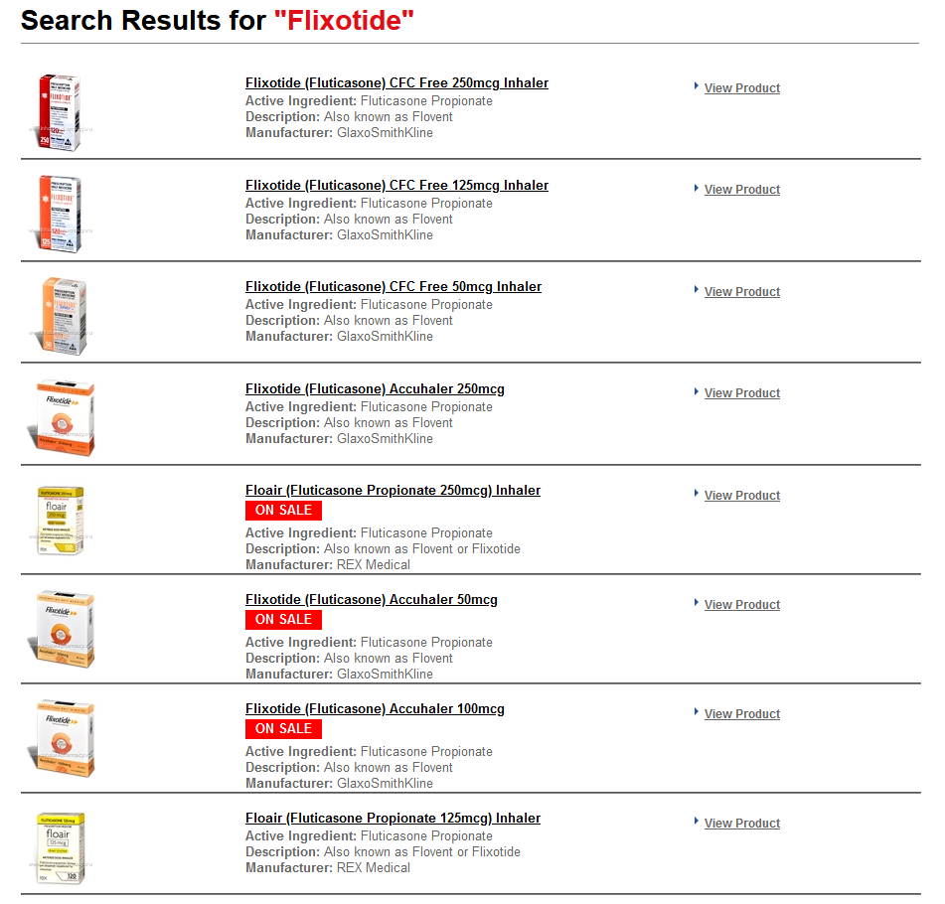

Revised:

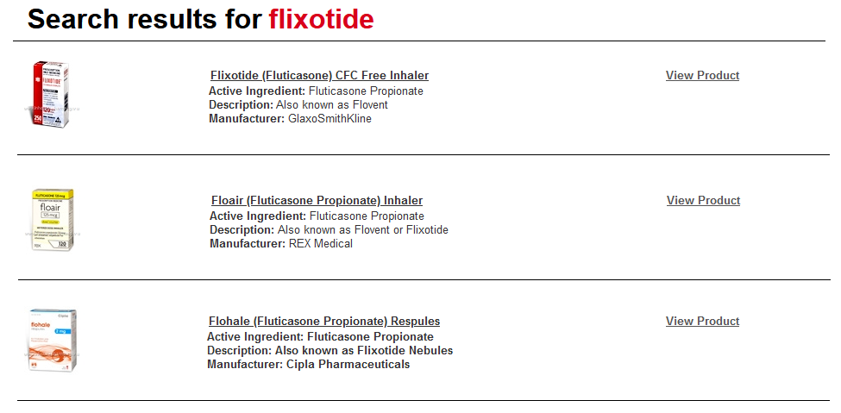

And these are the changes to purchasing, showing the display of dosages.

Original:

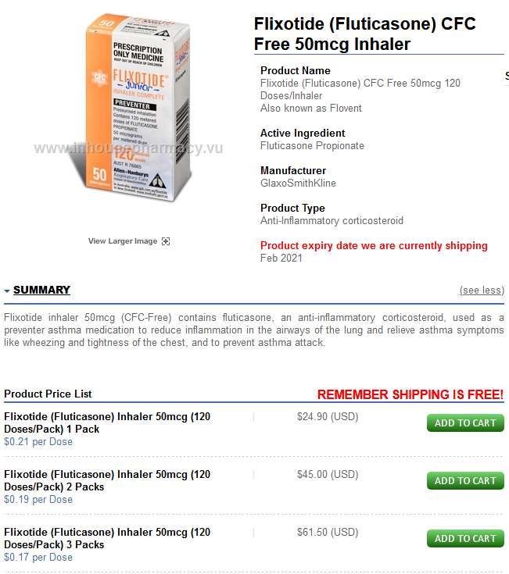

Revised:

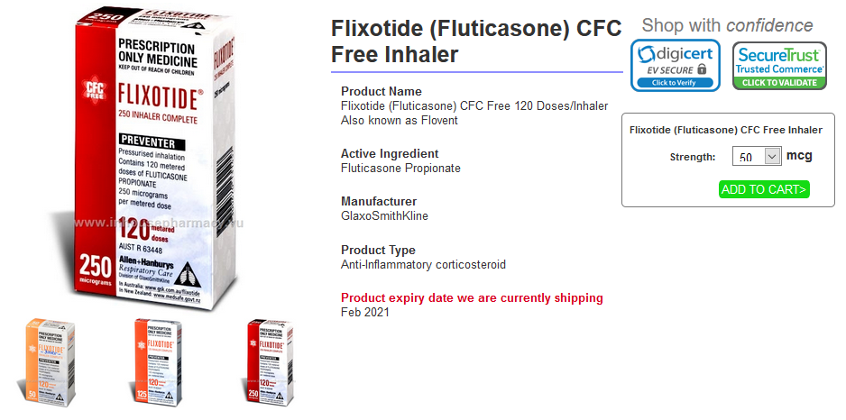

### Task #1 Prototype Rational

By compressing the number of items on the search list, it would be easier to find the particular product desired. In addition, using a drop-down menu for dosages prevents accidentally selecting the wrong dosage in the search results and purchasing it. Instead, there is a conscious evaluation of what strength because of its proximity to the “Add to cart” button. These changes promote clarity when making decisions.

## Task #2

### Task #2 Design

In the original website, this task is doable by going to the “Pet Care” page or by searching for Kiwof and selecting the appropriate medication in the search results. However, ordering the appropriate amount to complete the task is time consuming because the dosage information is located at the very bottom of the page, necessitating some level of scrolling. In the prototype, this information is in a table underneath the purchase button for easy viewing. In addition, determining the dosage is done through drop-down tables rather than multiple buttons.

### Task #2 Design Justifications

It is likely that the users of Inhousepharmacy.vu are people purchasing medication for themselves and not officially prescribed by a physician. Thus, important information such as dosages should be read by consumers who are looking to use the product and be in an easily accessible place when considering making a purchase.

### Task #2 Prototype

Although the prototype also has all of the dosage information in the original location, it also has it in a table beneath the option of adding it to the cart. Dosages are no longer separate buttons, but a single drop-down menu.

Original:

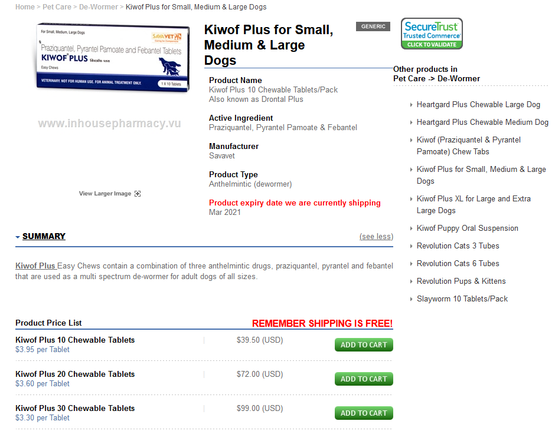

Revised:

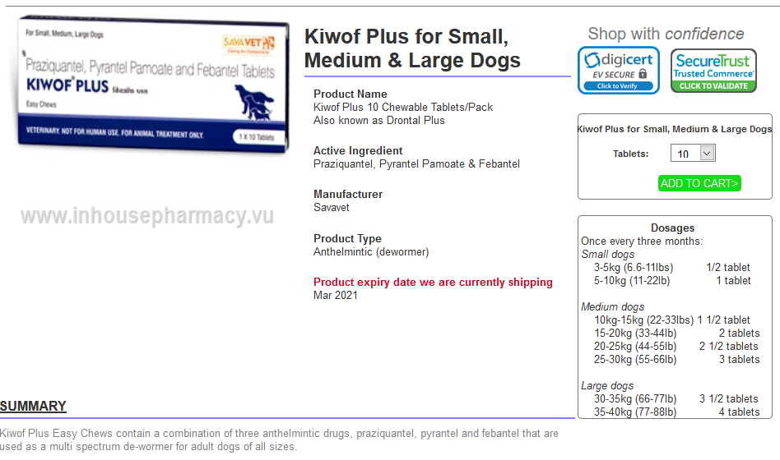

### Task #2 Prototype Rational

Having dosages be determined through drop-down menu rather than multiple buttons was seen as a way to make the page more compact. The dosage table is for the sake of expediting the ordering process by providing key information in a quickly accessible space, rather than towards the end of the page.

## Task #3

### Task #3 Design

The task asks for the user to locate a brand-name and a generic version of the same type of medication in the “Men’s Health” section and purchase both. This is problematic in the original website because while the website makes the distinction between brand-name and generic clear, it does not bother putting medicine of the same type next to each other for clarity.

### Task #3 Design Justifications

This task is primarily about whether or not simply rearranging the layout of medications to be more cohesive/intuitive can improve the speed of navigation or purchasing.

### Task #3 Prototype

In the prototype, the primary change is the rearrangement of items so that the same type of medication is next to each other, such as brand-name vardenafil being next to generic brand vardenafil, rather than brand-name vardenafil next to generic sildenafil. This is to make comparing medications easier and quicken searching. In addition, like with the other tasks, multiple dosages are condensed into one item to reduce clutter.

Original:

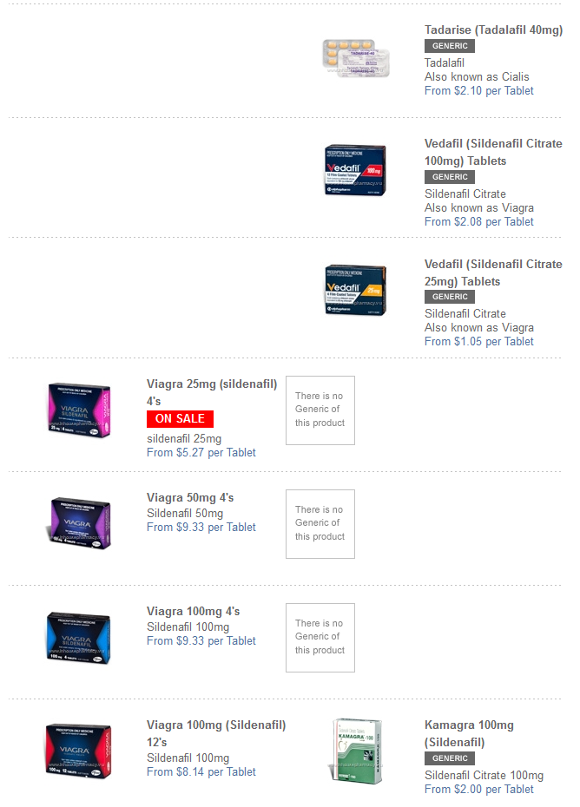

Revised:

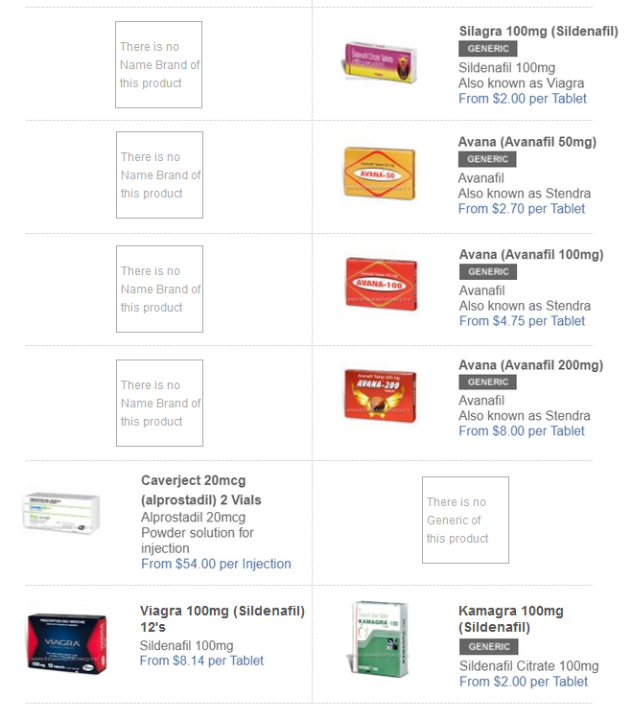

### Task #3 Prototype Rational

The idea behind rearranging the placement of items and clarifying the difference between brand-name and generic is to visually put the two together so that consumers have the option of quickly checking both items for comparison when thinking about making a purchase. In addition, it should be intuitive that like medicines are next to each other, rather than have them arranged in a haphazard order.

# A/B Testing

## Participants

Each member of the project team was tasked with finding 4 participants for testing--two for the original website, and two for the redesign--for a total of 16 participants. Reaching out to relatives and friends was recommended, as we would be unable to provide compensation.

## Scenarios

The following are the various tasks that the user will be asked to perform for this experiment. The researcher will give out instructions using the content in Appendix 6.4.

**Task 1:**

Search for Flixotide, 50mcg dosage accuhaler, add 1 pack to the cart, navigate to the cart, enter order information, and place the order.

**Task 2:**

Search for Kiwof Plus for Small, Medium & Large Dogs medication, add an amount of medicine equivalent to one year (12 months) worth of doses for a 22kg dog to the cart, navigate to the cart, remove it from the cart, and navigate back to the home page.

**Task 3:**

Navigate to the “Men’s Health” page, locate both a name-brand and generic version of the same erectile dysfunction medication (same dosage, some tablet count), and add them both to the cart.

## Equipment

For testing, each team member was asked to furnish a laptop or desktop computer that could run Axure RP9, as well as access the original website in a browser. To record mouse movement and tester experience, we utilized a free screen-recording software, called Loom. The “Instructions for Participants” page (found in Appendix 6.4) was printed out and handed to each participant at the time of testing.

## Subjective Metrics

***Overall User Satisfaction:***

The participants will be given a background questionnaire (Appendix 6.6) to obtain a better understanding of the user’s demographics, knowledge of InHousePharmacy.vu and other online pharmacy sites, and ecommerce experience. The results of this survey will help give the team vital data determine whether or not having prior knowledge to the tasks correspond to faster time on tasks, lower errors, or a difference in satisfaction levels.

The participants will also be given a post session questionnaire (Appendix 6.7). This will help to determine the overall user satisfaction with the original website versus the redesigned prototype. The post session questionnaire will be based on the Likert Scale (Strongly Disagree = 1, Disagree, Neutral, Agree, Strongly Agree).

## Quantitative Metrics

***Time on Task:***

The participants will each complete the three tasks outlined in this document (8 on the original, 8 on the prototype). Each participant will be timed for each task. Mean time on task will be compared in order to tell the team whether or not the redesign was able to successfully reduce time on task. Finally, a T-Test will be done on each of the three tasks to determine the confidence in each test.

***Number of Errors:***

The participants will each complete the three tasks outlined in this document (8 on the original, 8 on the prototype). The team will record the number of errors for each participant. Mean number of errors will be compared to tell the team whether or not the redesign was able to successfully reduce the number of errors for each task. Finally, a T-Test will be done on each of the three tasks to determine the confidence in each test.

## Test results

**Test Results :** [**https://docs.google.com/spreadsheets/d/1aunImK_FaTRf1RYH7aKCCdASgIv1MBEmMsKyCfDwh5Y/edit?usp=sharing**](https://docs.google.com/spreadsheets/d/1aunImK_FaTRf1RYH7aKCCdASgIv1MBEmMsKyCfDwh5Y/edit?usp=sharing)

# Conclusions

## Discussion of Results

**Overall User Satisfaction:**

Because the absolute value of our t-value (5.11417) is greater than the critical value (1.7341), we reject the null hypothesis that the mean satisfaction scores of original and prototype are the same. Therefore, we can say with some degree of certainty that the prototype resulted in a higher level of satisfaction for end users.-

**Time on Task:**

Because the absolute value of our t-value (0.1432) is less than the critical value (1.7613), we accept the null hypothesis that the mean time on task 1 of original and prototype are the same. Therefore, we cannot say with any degree of certainty that the prototype resulted in a lower time on task for task 1.

Because the absolute value of our t-value (2.43644) is greater than the critical value (1.7613), we reject the null hypothesis that the mean time on task 2 of original and prototype are the same. Therefore, we can say with some degree of certainty that the prototype resulted in a lower time on task for task 2.

Because the absolute value of our t-value (2.38248) is greater than the critical value (1.7613), we reject the null hypothesis that the mean time on task 3 of original and prototype are the same. Therefore, we can say with some degree of certainty that the prototype resulted in a lower time on task for task 3.

**Number of Errors:**

Because the absolute value of our t-value (1) is less than the critical value (1.7613), we accept the null hypothesis that the mean number of errors on task 1 of original and prototype are the same. Therefore, we cannot say with any degree of certainty that the prototype resulted in a lower number of errors for task 1.

Because the absolute value of our t-value (1.5275) is less than the critical value (1.7613), we accept the null hypothesis that the mean number of errors on task 2 of original and prototype are the same. Therefore, we cannot say with any degree of certainty that the prototype resulted in a lower number of errors for task 2.

Because the absolute value of our t-value (2.443) is greater than the critical value (1.7613), we reject the null hypothesis that the mean number of errors on task 3 of original and prototype are the same. Therefore, we can say with some degree of certainty that the prototype resulted in a lower number of errors for task 3.

## Lessons Learned

A significant lesson learned from this project was the number of variables you have to account for when designing a website. When there are a number of different approaches to solving a given problem, each potential solution has to be carefully designed to each be satisfactory for users. For instance, the different means of finding products by searching or by browsing the subcategories listed at the top of the website each have different strengths and weaknesses that we had to overcome in our design. Changes in each additionally have to be made with respect to what the goals of users who pick one over the other may be.

## Conclusion

In the end, the changes we made in our redesign had a positive impact on the experience of users. In our third task in particular, the time on task and number of errors decreased significantly, which seems to indicate that we succeeded in fixing one of the more significant issues with the original website’s design. Still, while our quantitative metrics for task 1 may have failed to reject the null hypothesis, it seems likely that this may be a result of our changes in regard to that task may simply have had a more subtle positive impact, which would be sufficiently confirmed with a larger sample size of participants. In summation, we believe that our redesign was a successful step in the right direction for the design of this website.

# Appendices

## Heuristic Evaluation <https://drive.google.com/open?id=18paak3NkMPL0abxXkULwHXC-2KGIEI8t>

## Cognitive Walk-through<https://drive.google.com/file/d/1zI407Quw63d0kf5HcdvNGG58TDKL5Up-/view?usp=sharing>

## New GUI snapshots

## Prototype Link: gfi9hu.axshare.com

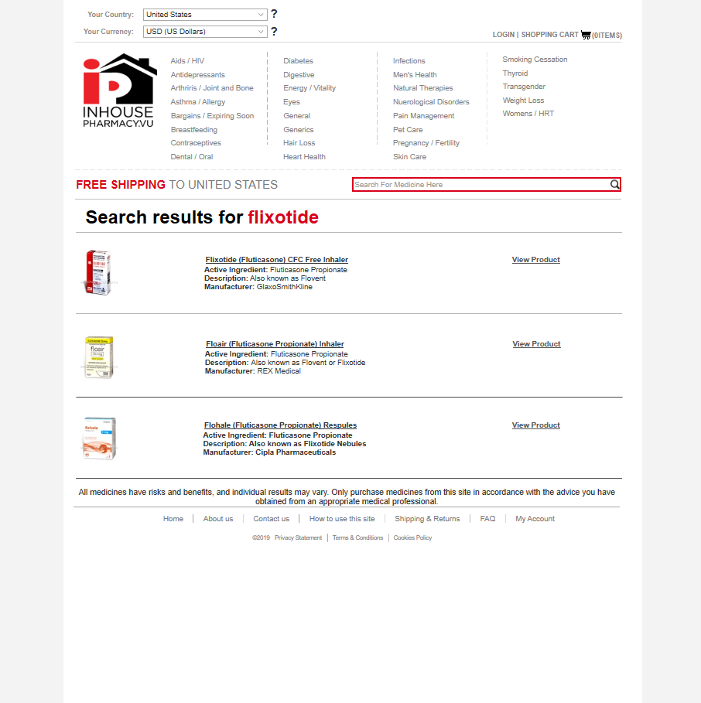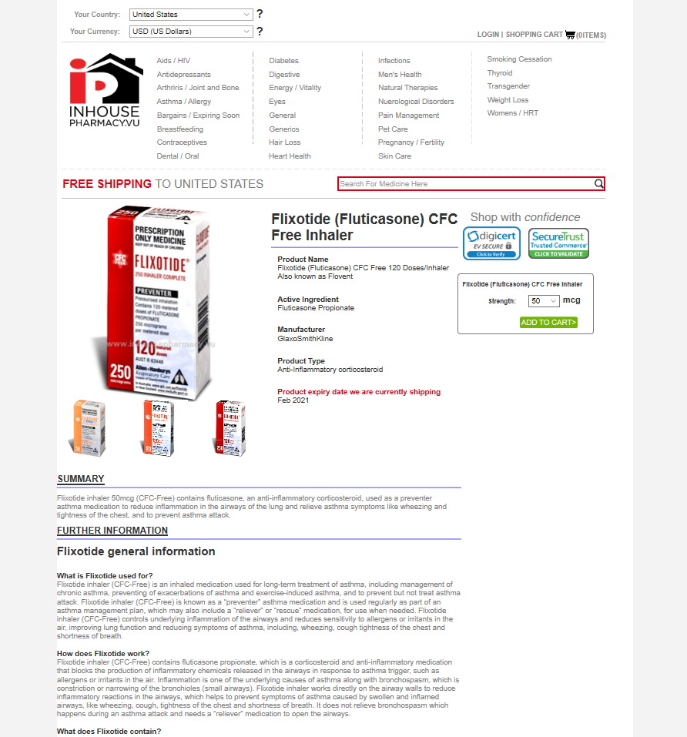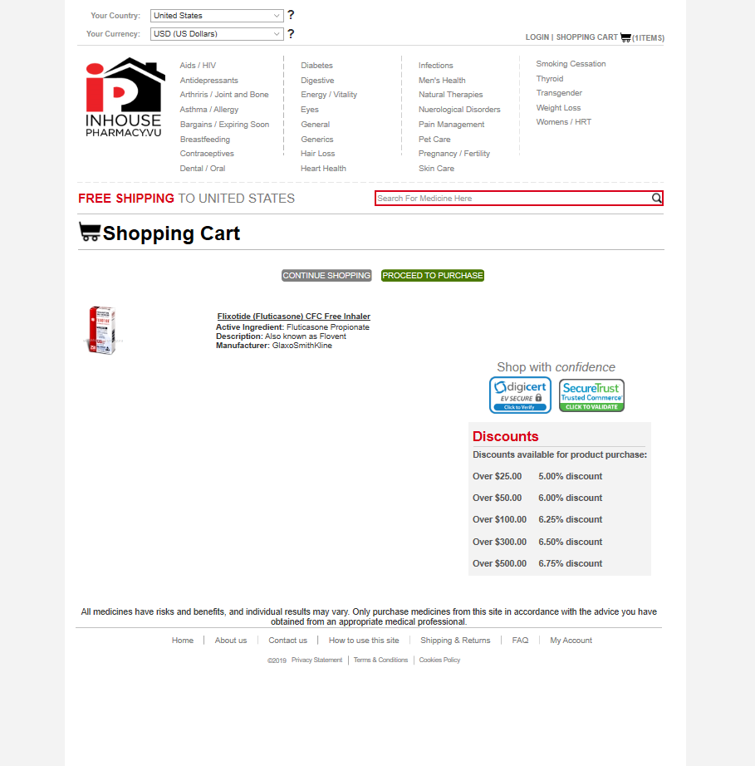

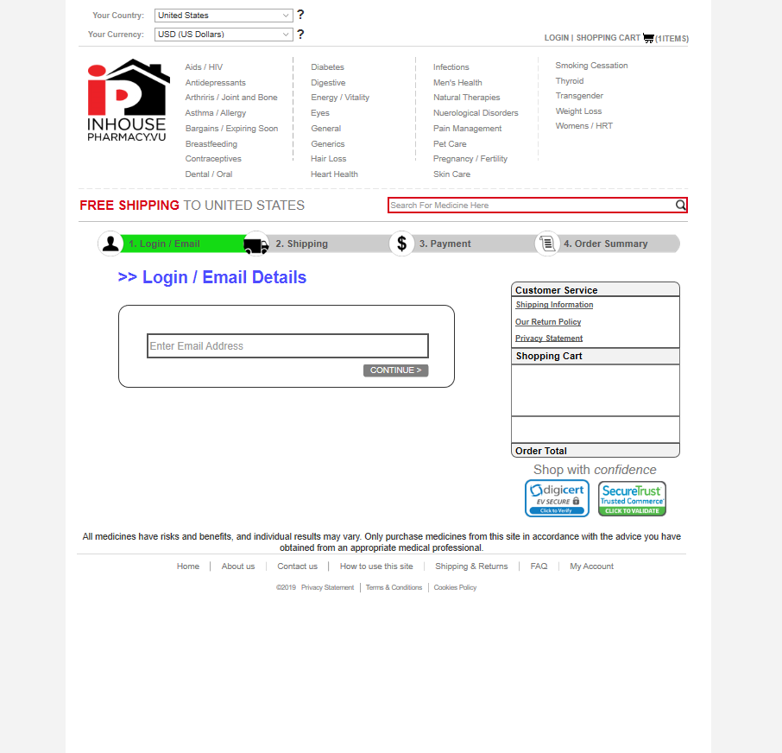

## Instructions for Participants

**Participant Instructions:** [**https://drive.google.com/file/d/1RX1mV0gYfwPXQ_3NYCyO0XaVasncCsPb/view?usp=sharing**](https://drive.google.com/file/d/1RX1mV0gYfwPXQ_3NYCyO0XaVasncCsPb/view?usp=sharing)

## Researcher guidelines

**Pre - experiment**

Thank you for participating in this experiment. The goal of this experiment is to test a possible redesign of a website is more efficient in terms of time and performance of a task as well as user satisfaction. The website in question is a website that sells pharmaceuticals online. The experiment will be conducted in three parts. The first part is a questionnaire that seeks to evaluate your preexisting knowledge about online shopping and medications. The second section will involve using either the current website or a prototype created using Axure, prototyping software, to complete some tasks. Lastly, the third section is another questionnaire about one’s thoughts and experiences relating to the website or prototype.

**Quiz**

The purpose of this quiz is to get a better understanding of your knowledge of shopping websites and prescription medication. This will be used to see if there is any correlation between medicinal familiarity and the amount of time it takes to complete a task. Please answer questions to the best of your ability, and if you do not know how to answer them, leave the answer blank.

**Experiment**

The following instructions should be used to complete the tasks given. When starting a new task, please empty the cart using the instructions provided and go back to the home page by clicking on the associated link at the bottom. If there are any questions about the tasks, please ask so that I can clarify. When you are done with the tasks, signal that you are so that further instruction can be provided.

[Give them a copy of “Instructions for participants” to read]

**Post-experiment**

Thank you for participating in this experiment and for using this website/prototype. The last remaining step is to complete a survey asking about your experience with this website/prototype. Please be honest with your answers for every question.

The survey is right here. [Provide written survey.]

Once again, thank you for participating.

## Background questionnaire

Answer the following questions to the best of your ability. If you do not know the answer to a question, please leave the answer blank.

1. Have you used a shopping service website before? Yes or no.
2. Name the aspect of a shopping service website you find most important that relates to the website, not delivery.
3. Have you ever ordered medication online? Yes or no.
4. Do you know the difference between brand-name medication and generic medication? Yes or no.
5. Do you know any brand-name asthma/allergy medications or their generic counterparts? If so, please list them and label what category they belong to.
6. Do you know any brand-name pet care medications or their generic counterparts? If so, please list them and label what category they belong to.
7. Do you know any brand-name influenza medications? If so, please list them and label what category they belong to.

**Background Questionnaire Survey Results :** [**https://drive.google.com/open?id=1w8mZTRVvKFjntRfe-hCS-3T3qJvQ7KOqe-dmZLz2rMc**](https://drive.google.com/open?id=1w8mZTRVvKFjntRfe-hCS-3T3qJvQ7KOqe-dmZLz2rMc)

## Post-session questionnaire

1. I would like to use this website for ordering medication
   1. Strongly disagree
   2. Disagree
   3. Neutral
   4. Agree
   5. Strongly agree
2. I thought this website was easy to use
   1. Strongly disagree
   2. Disagree
   3. Neutral
   4. Agree
   5. Strongly agree
3. I thought this website was overly complex
   1. Strongly disagree
   2. Disagree
   3. Neutral
   4. Agree
   5. Strongly agree
4. I thought this website frustrating to use
   1. Strongly disagree
   2. Disagree
   3. Neutral
   4. Agree
   5. Strongly agree
5. The layout of this website was clear to understand
   1. Strongly disagree
   2. Disagree
   3. Neutral
   4. Agree
   5. Strongly agree
6. I would need more background information to use this website
   1. Strongly disagree
   2. Disagree
   3. Neutral
   4. Agree
   5. Strongly agree
7. I would need someone else’s assistance to use this website
   1. Strongly disagree
   2. Disagree
   3. Neutral
   4. Agree
   5. Strongly agree
8. I felt confident using this website
   1. Strongly disagree
   2. Disagree
   3. Neutral
   4. Agree
   5. Strongly agree
9. I would recommend this website to a friend
   1. Strongly disagree
   2. Disagree
   3. Neutral
   4. Agree
   5. Strongly agree
10. I think navigating this website is easy to learn
    1. Strongly disagree
    2. Disagree
    3. Neutral
    4. Agree
    5. Strongly agree

**Post-Session Questionnaire Survey Results:** [**https://docs.google.com/spreadsheets/d/1BaIo4IT_--igO6sz_hYjT54QMLrhfayeMIlVC9PX0mo/edit?usp=sharing**](https://docs.google.com/spreadsheets/d/1BaIo4IT_--igO6sz_hYjT54QMLrhfayeMIlVC9PX0mo/edit?usp=sharing)